**Department of Information Technology**

**Delhi Technological University**

**Database Management System**

**Project Report**

***“HOTEL MANAGEMENT SYSTEM”* **

**Submitted By:**

**Name: Roll No:**

Vikas Bhandari 2K19/IT/142

Utkarsh 2K19/IT/136

###### Submitted To: Ms. Swati Sharda

**ACKNOWLEDGMENT**

We (Vikas Bhandari and Utkarsh) would like to express our sincere gratitude to our supervisor Ms. Swati Sharda for providing her valuable guidance, comments and suggestions throughout the course of the project. We would like to thank her for providing us the opportunity to work on the topic - “***Hotel Management System”.***

We would also like to thank my fellow classmates who have been very supportive and have motivated us throughout the course of the project.

Lastly, we would like to mention our parents who have helped and guided us to focus on our project. They taught us the basic ethical principles that one must follow in life which has ultimately led to the successful completion of the project.

We hope you have a great time while reading the project!

# **PROJECT DESCRIPTION**

***Hotel Management System***

* This is a web-based application project for hotel management system.
* By using this website the user can see the features and services offered by the hotel and can book rooms as per his requirement.
* Also there is admin section in the website which can only be accessed by the designated person by the hotel with a login id. In admin section, the admin can perform operations like booking, unbooking, editing the customer details etc.

**OBJECTIVE OF THE PROJECT:**

The website will help users to Book rooms in UV Hotels by selecting the type of room. We have also created an admin panel where the staff of the Hotel itself can book rooms and also unbook them if the user tell them to do so.

**MOTIVATION BEHIND THE PROJECT:**

The main motive behind this project is that since we were learning web development so we wanted to make such a website.

By working on this project, we also got to learn about various constraints to apply which is an integral part of database management system and improve our web development skills.

**Language Used:** html, css, php and javascript

**Overview:**

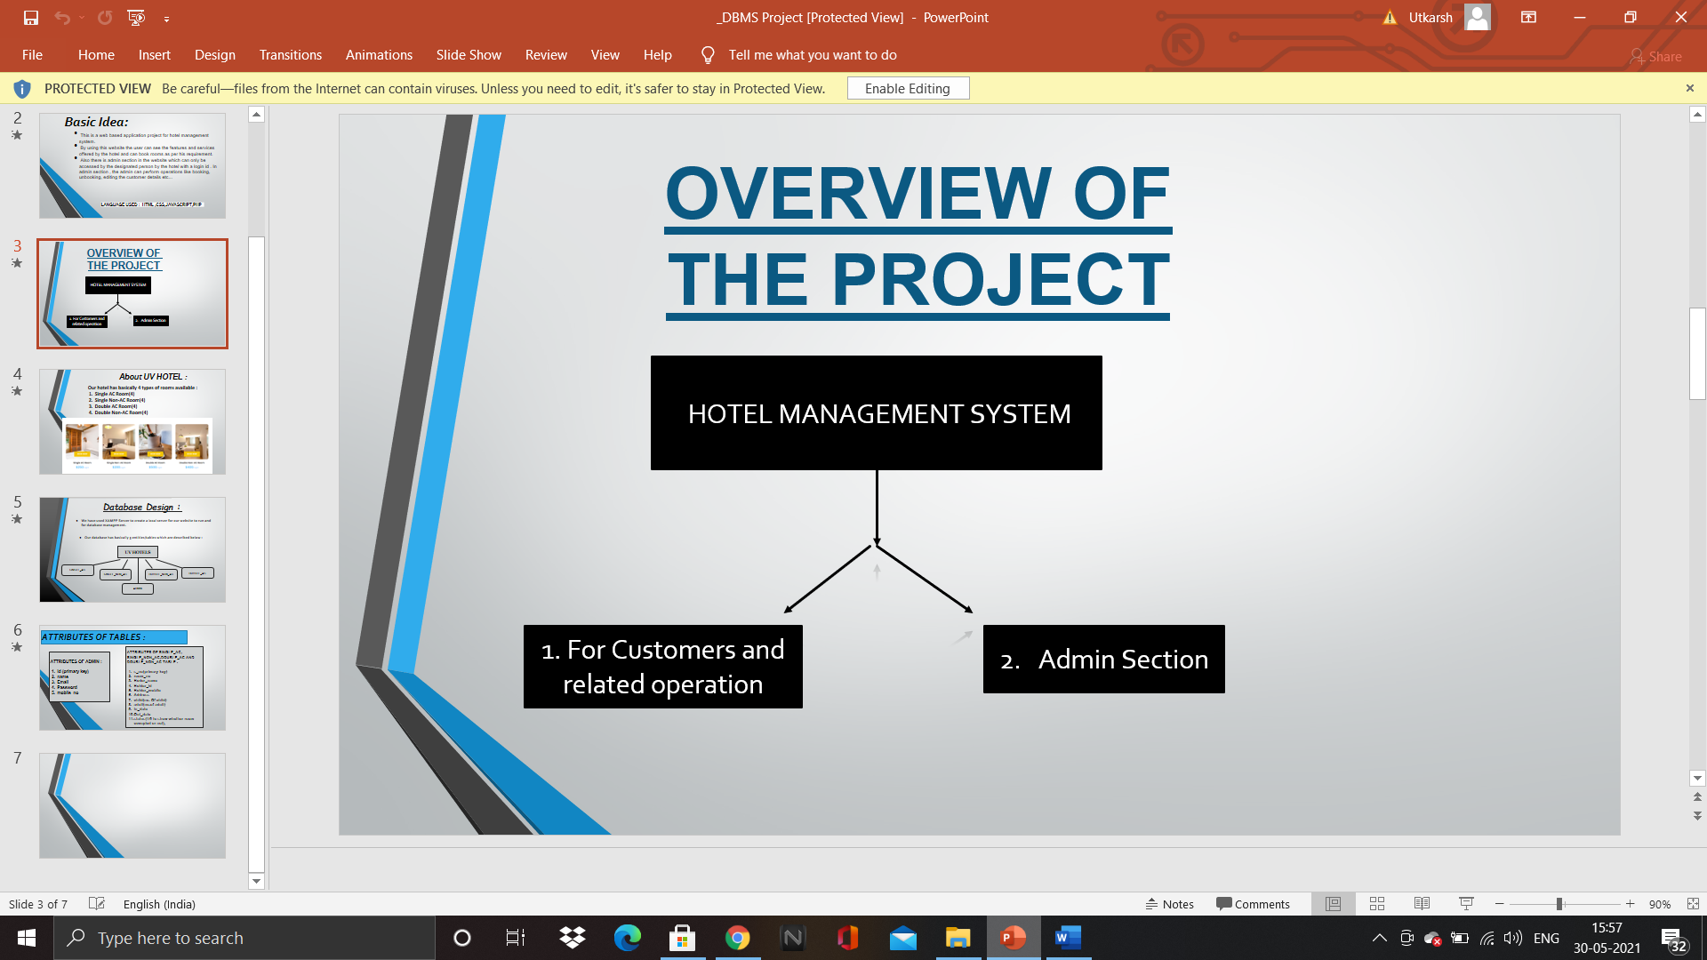

**About UV Hotels:**

Our hotel has 4 types of rooms:

1) Single AC Room (4)

2) Single Non-AC Room (4)

3) Double AC Room (4)

4) Double Non-AC Room (4)

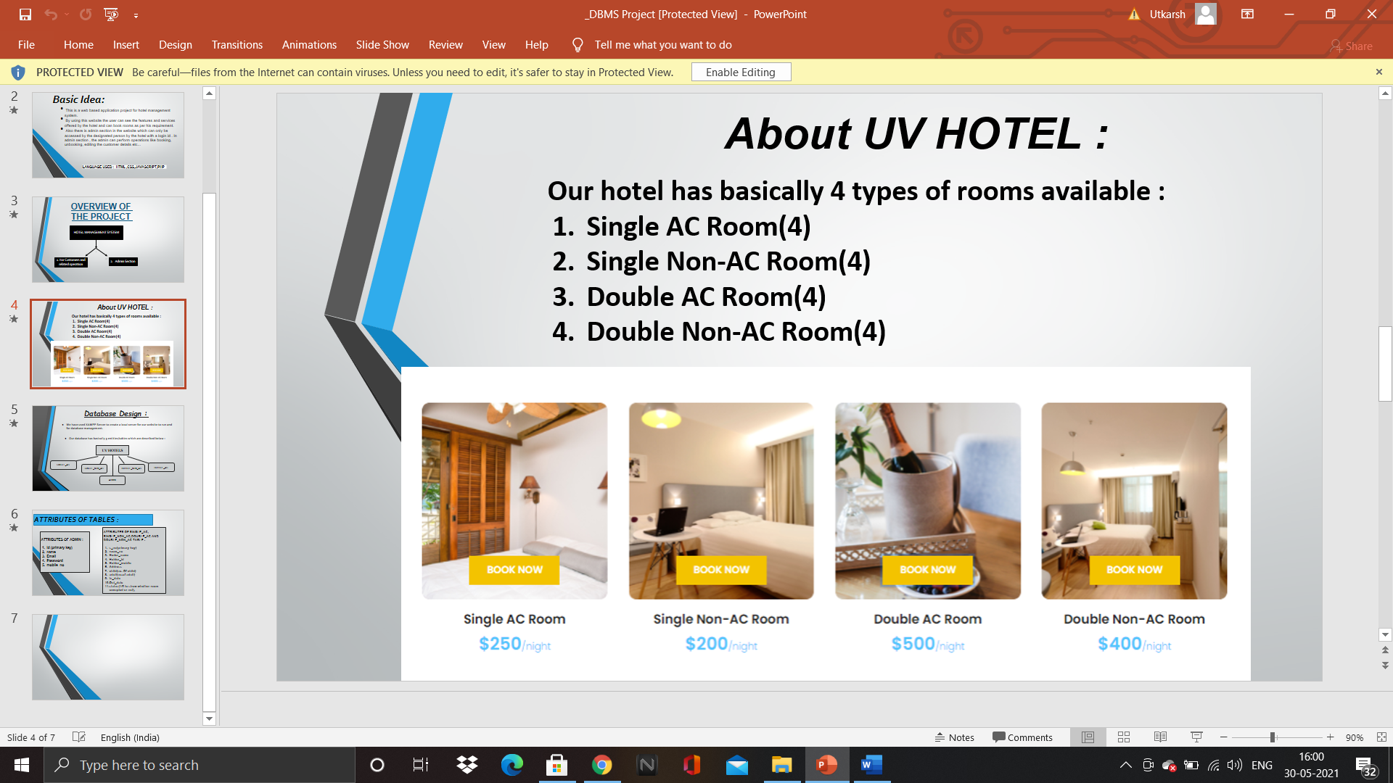

**Database Design:**

We have used XAMPP Server to create a local server for our website to run and for database management.

Our database has basically 5 entities/tables which are described below:

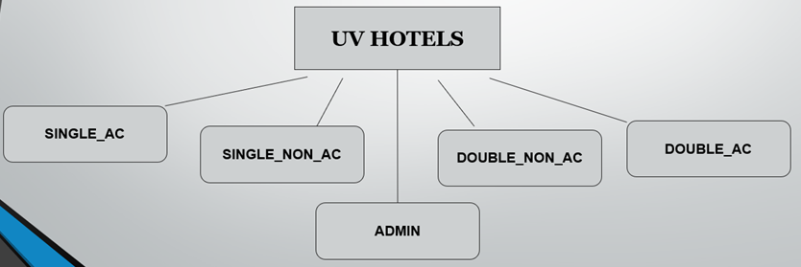

**Attributes of Tables:**

Attributes of all room type table:

1. s_no(primary-key)

2. room_no

3. Hoder_name

4. Holder_id

5. Holder_mobile

6. Address

7. child(no. Of child)

8. adult(no.of adult)

9. In_date

10.Out_date

11.status(1/0 to show whether room occupied or not)

Attributes of Admin Table:

1. Id (primary key)

2. name

3. Email

4. Password

5. mobile_no

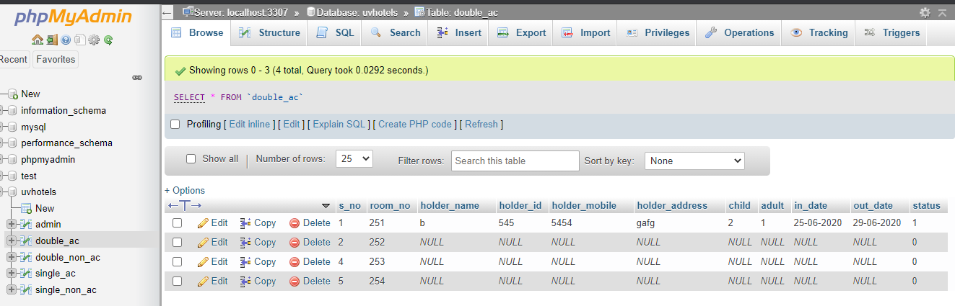

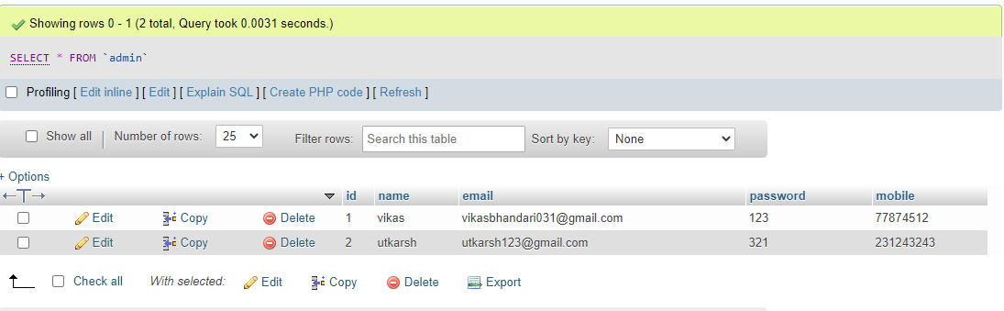

**ABOUT HOME PAGE:**

The homepage of our project is basically a landing page of our website i.e if a user opens our website then this would be the first page that he/she would be visiting. This page basically introduces what our whole website is all about.

This page contains navigation bar, developer’s information, booking room option etc. which are presented in a very interactive manner in the webpage so that user would find it

interesting to use the website.

Features of homepage :

1. Pictures of the Hotel
2. Reviews of Customers
3. Developer’s Information
4. Booking room option for the users

**Screenshots of the Home Page:**

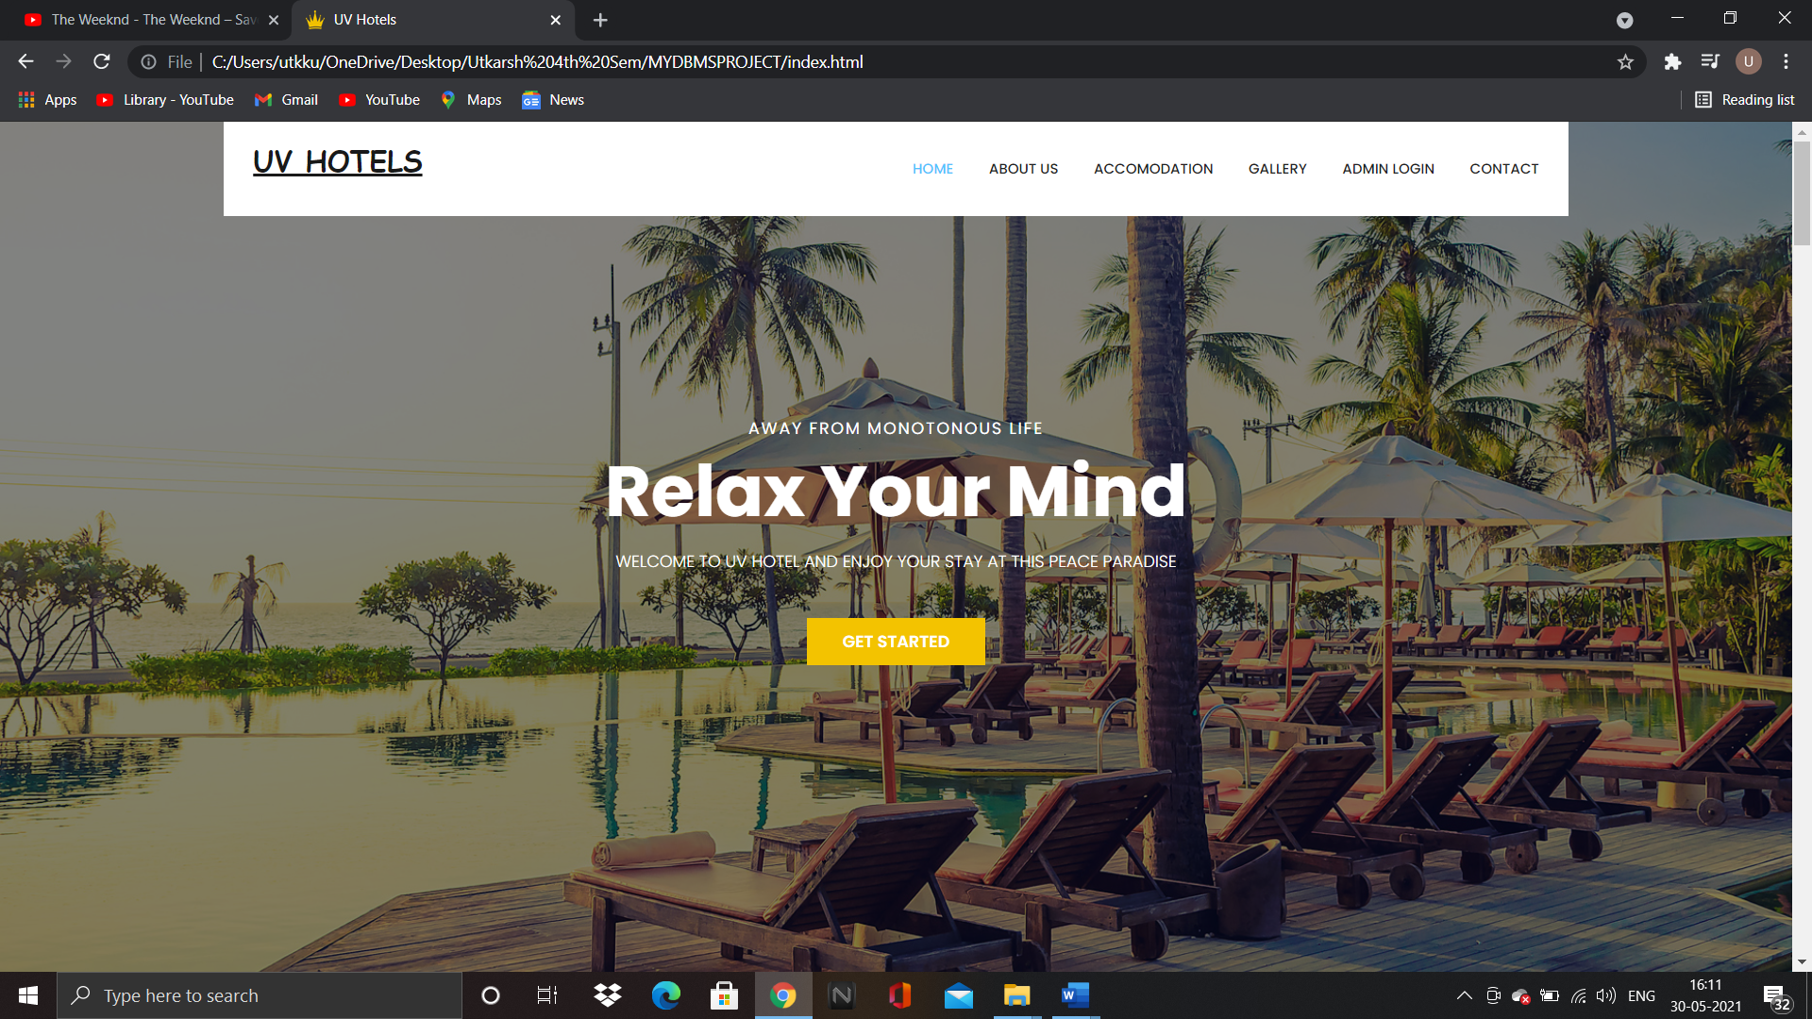

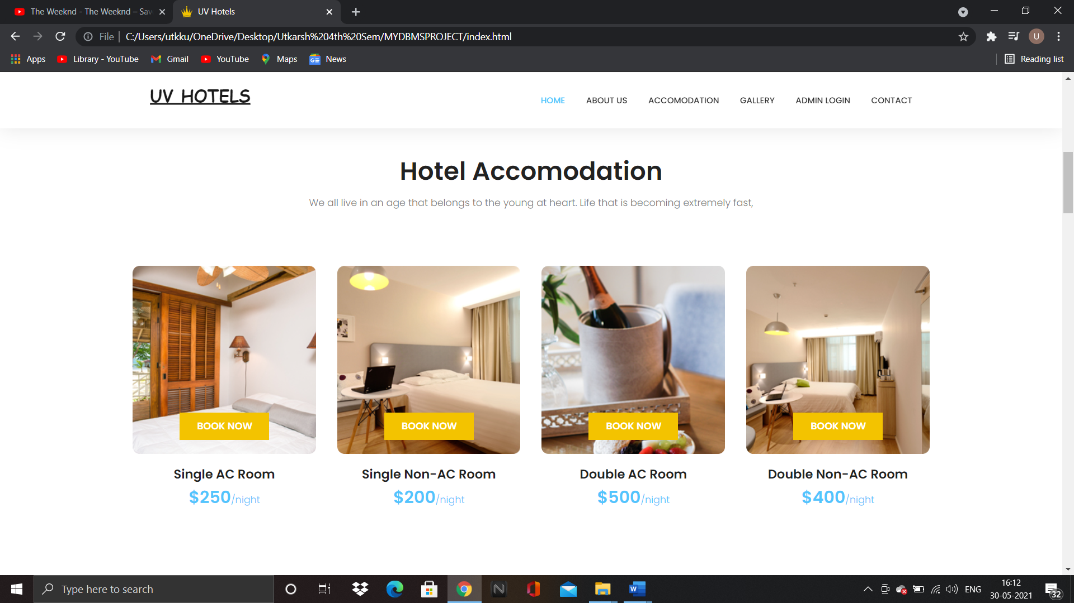

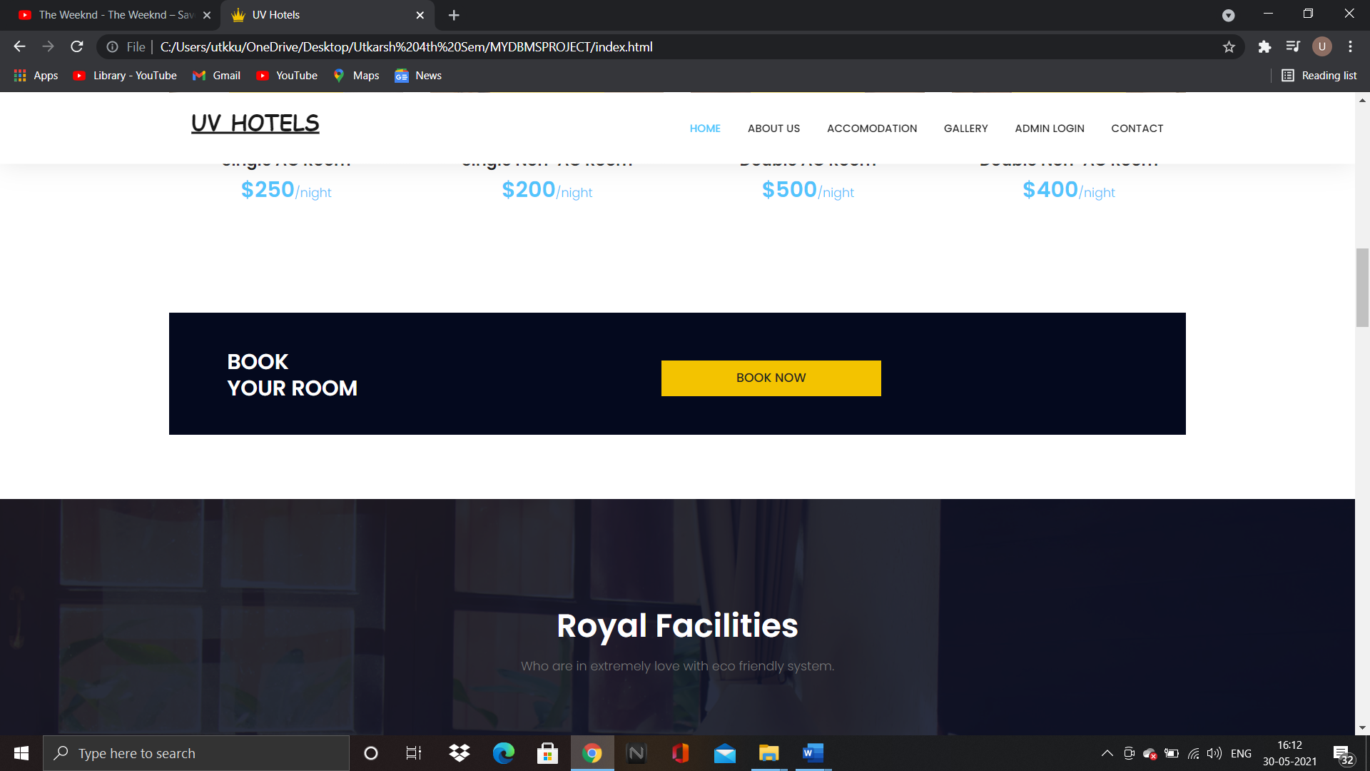

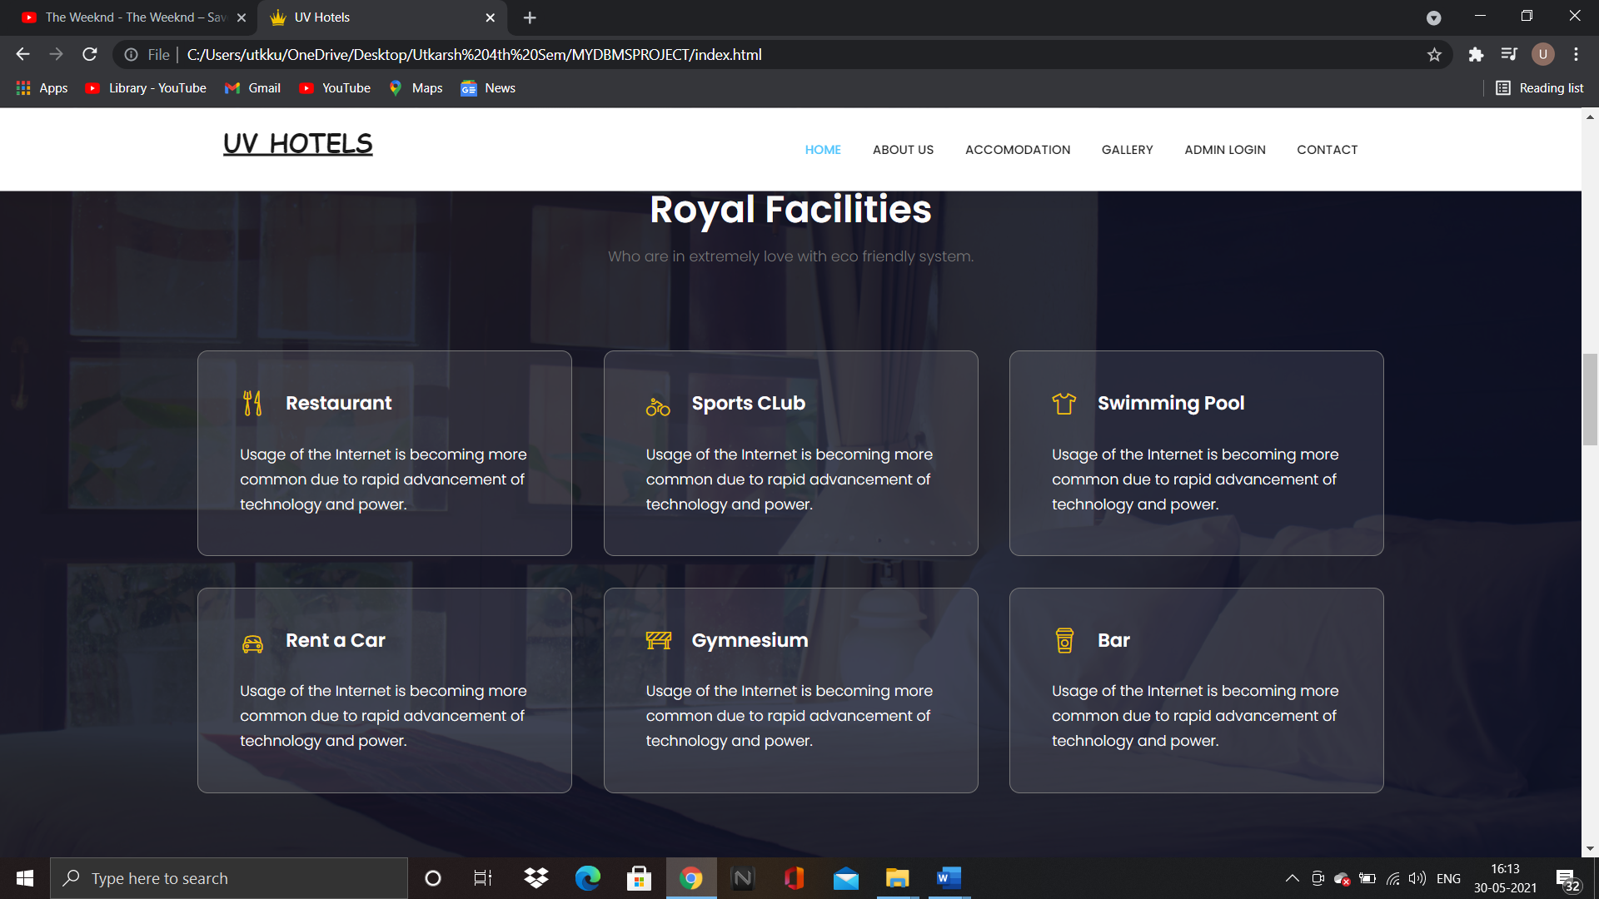

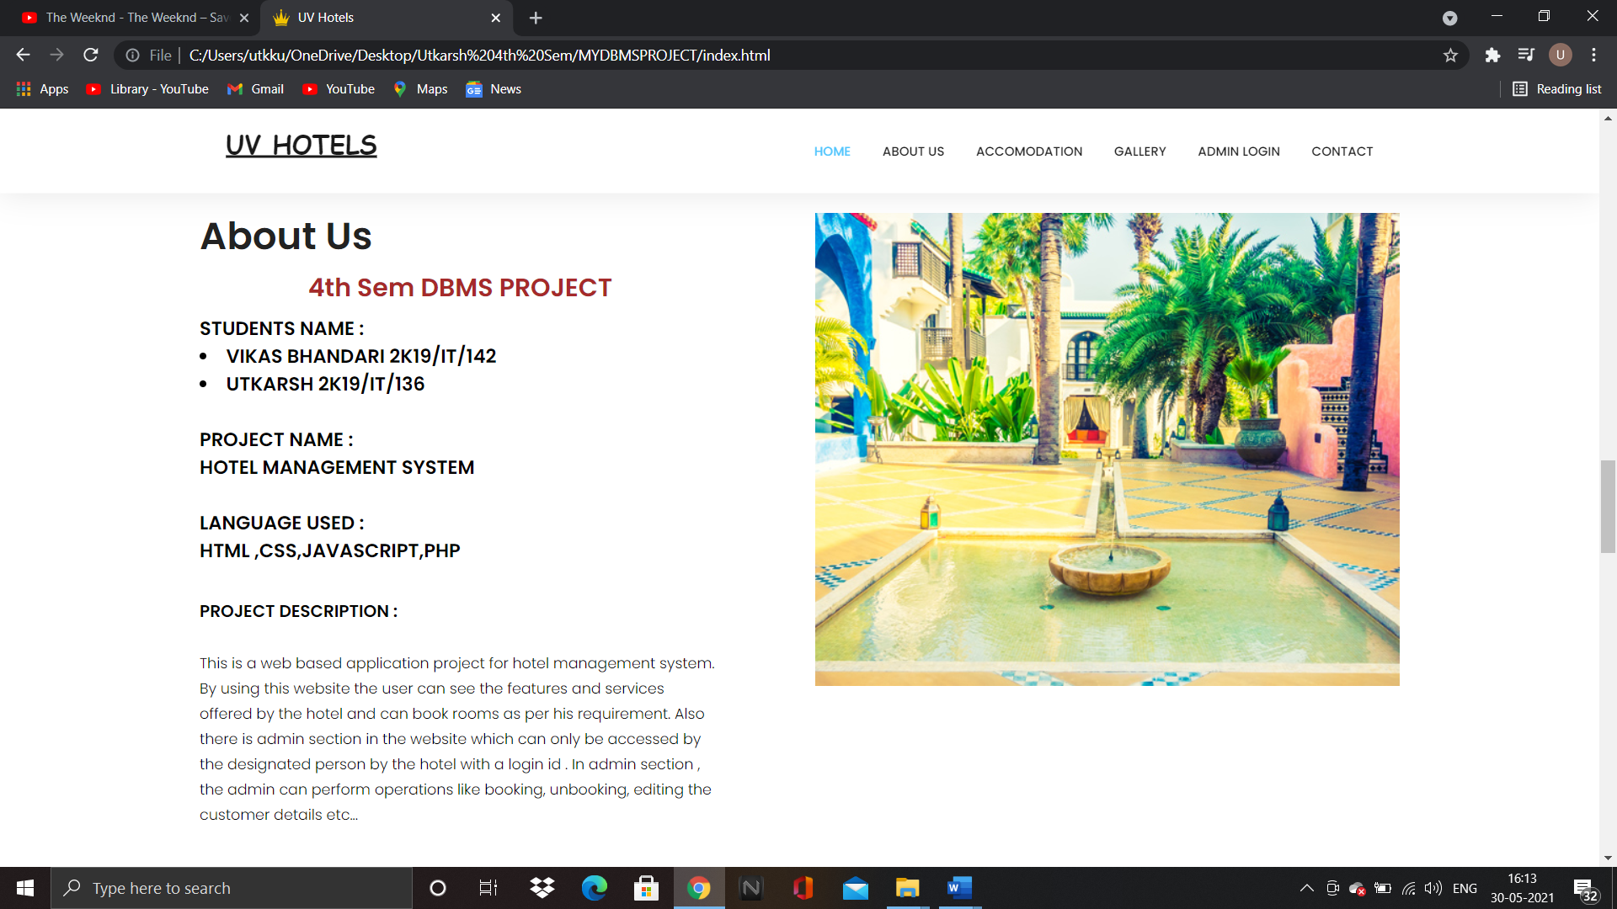

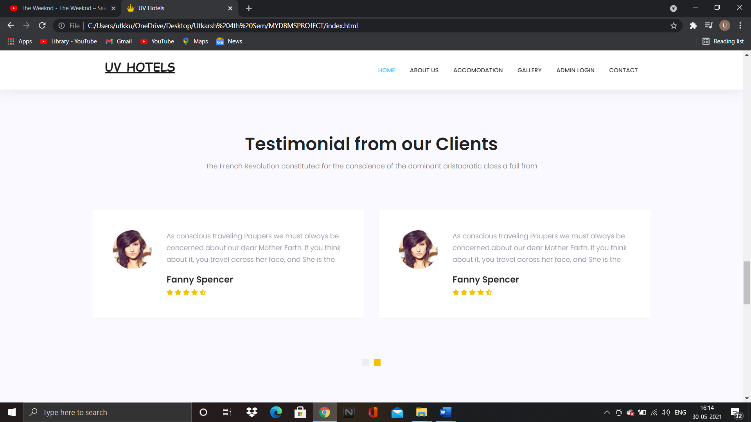

**Booking Room Option:**

1. When the user will click the Book Room option he will be redirected to a new page where all the available rooms will have the book room option available.
2. We have used the concepts of buttons and we have switched these buttons off where the rooms are already booked.
3. When the user will select the room a form will appear where the user will have to enter his details.
4. We have used the concept of urls to send the Room no. and Room type in this Form.
5. Once the user submits the form, the information gets inserted in the table in myphp.

**Screenshots:**

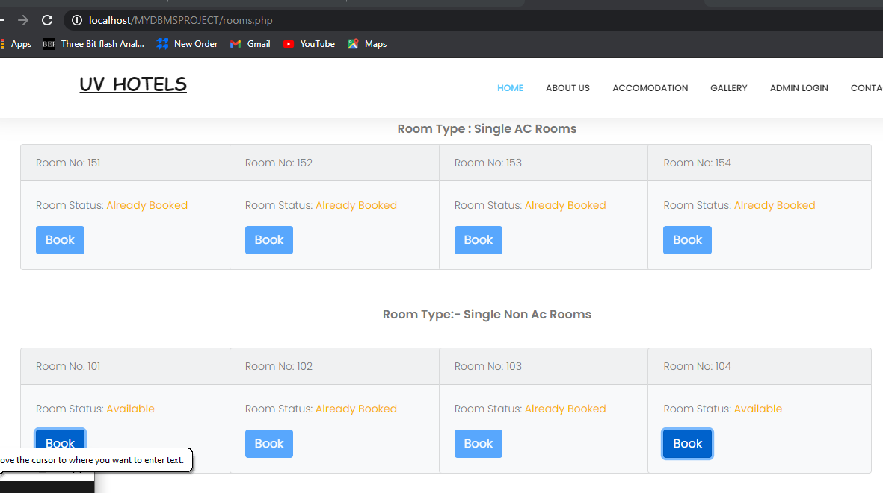

**About Admin Panel:**

1. This section has a special option for the staff of the hotel to Unbook a room on user’s request.
2. The rooms that are available have the unbook button switched off and the rooms that are already booked have the unbook button switched on.
3. Once the user unbooks a room the information in the table gets deleted.

**Screenshots:**

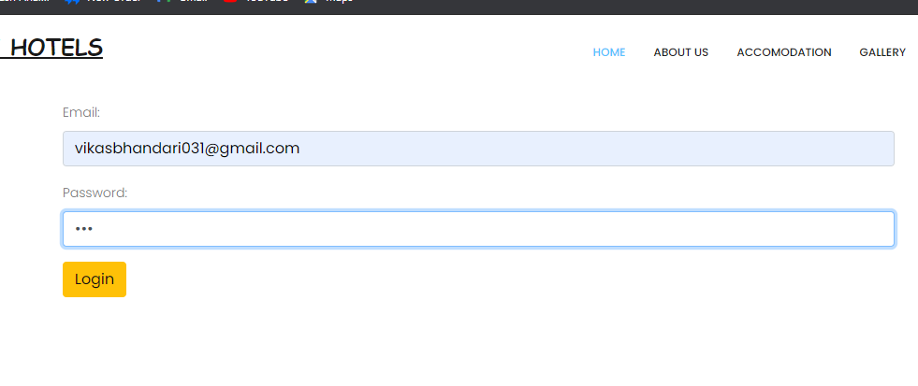

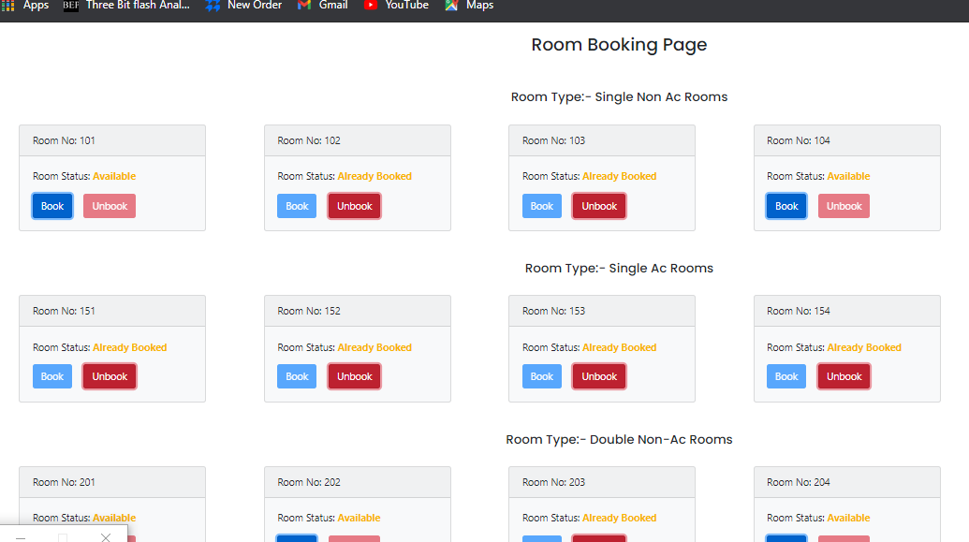

**Project Link :**[**https://drive.google.com/drive/folders/1cTocvGilbYqpedCdOoRVhht-soS1nFvO?usp=sharing**](https://drive.google.com/drive/folders/1cTocvGilbYqpedCdOoRVhht-soS1nFvO?usp=sharing)